**Lab Guide 7**

Managing Resources : Resources in Deployments, quota

Q.2 Create a deployment with cpu and memory limits only with 200mb ram and 400m cpu value.

Q.3 Create a deployment with cpu and memory limits and requests also with any value.

Q.4 create a quota in your own namespace that pods=4, svc=2

Q.5 Create one Limit range with any value.

Ans: 2

vim dep.yaml

cat dep.yaml

oc create -f dep.yaml

oc describe deployment mayank

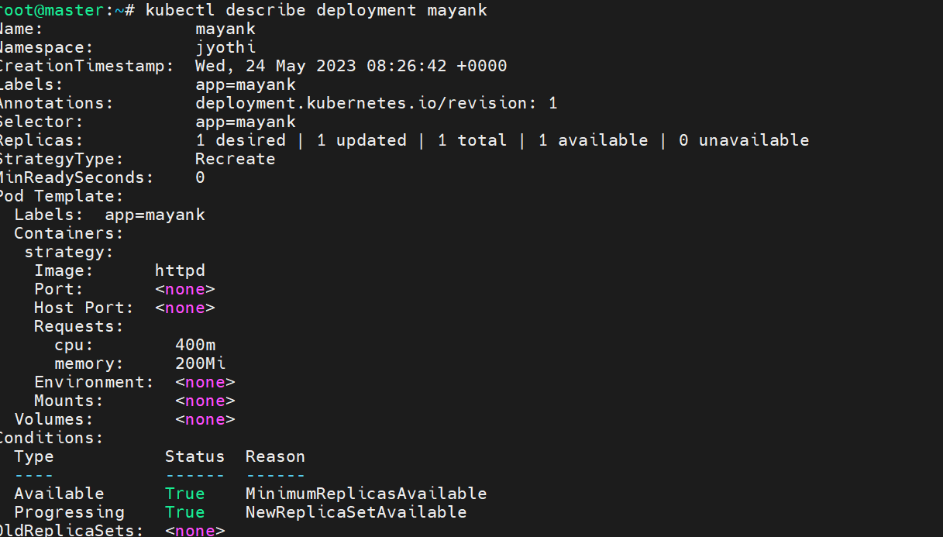

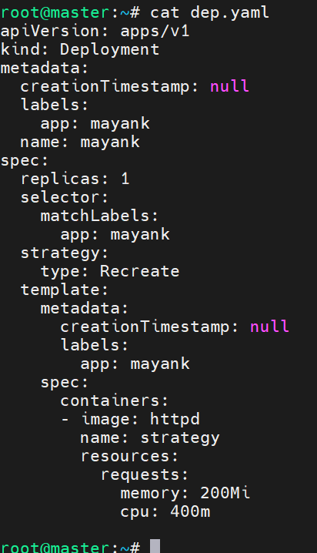

Ans: 3

oc apply -f dep.yaml

oc describe deployment mayank

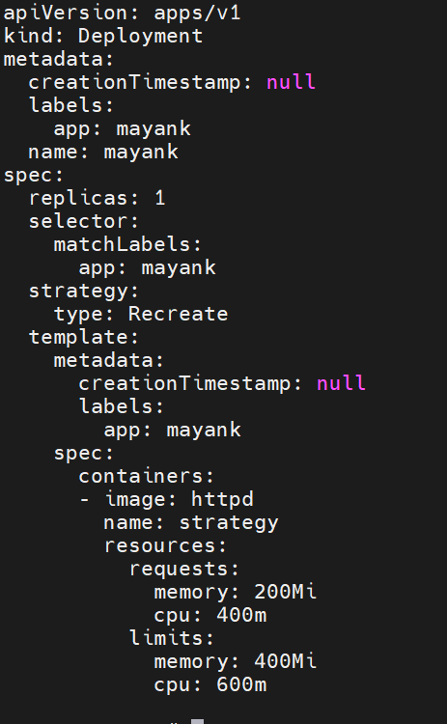

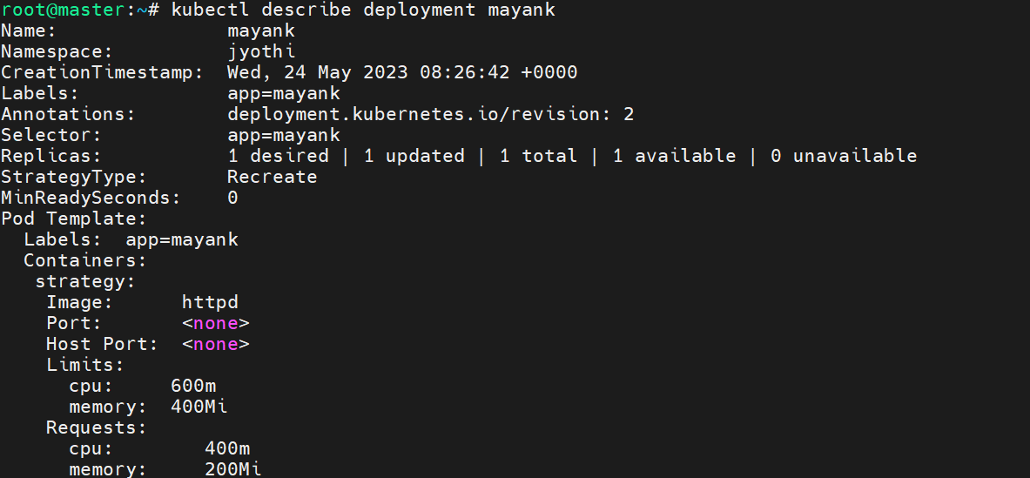

Ans: 4

oc create deployment mayank --image httpd

oc create quota mayankquota --hard=pods=4,services=2

oc scale deployment mayank --replicas 5

oc get pods

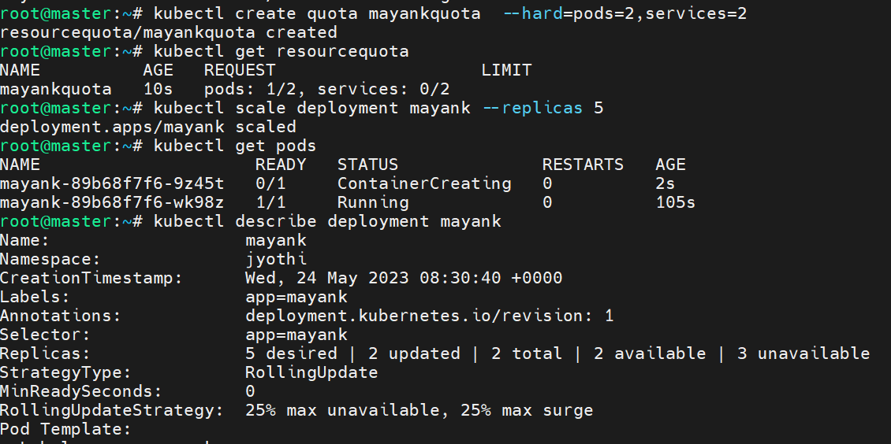

Ans : 5

Cat limitrnage.yml

apiVersion: "v1"

kind: "LimitRange"

metadata:

name: "resource-limits"

spec:

limits:

- type: "Container"

max:

cpu: "2"

memory: "1Gi"

min:

cpu: "100m"

memory: "4Mi"

default:

cpu: "300m"

memory: "200Mi"

oc create -f limitrange.yml

oc get limitrange

oc describe limitrange resource-limits

